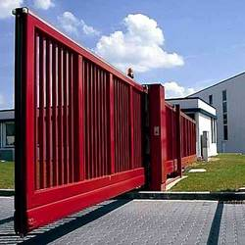
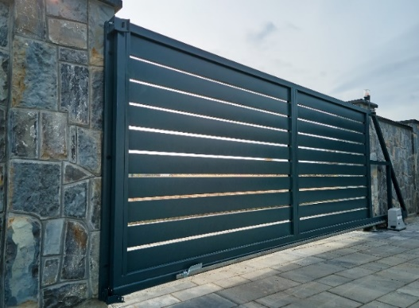

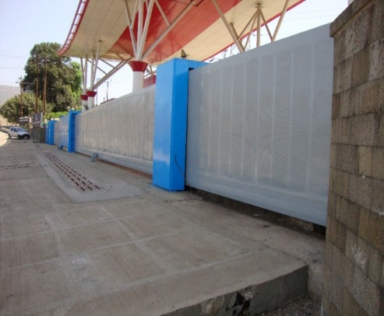
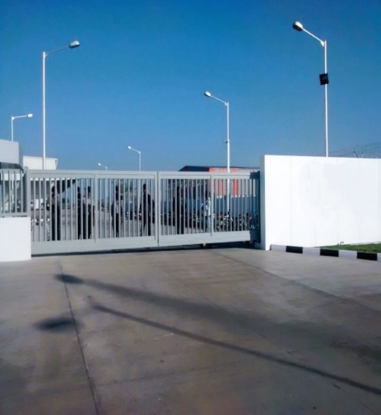
Motorized Cantilever Gate
- Noise-free movement of gate.
- No Track or concrete foundation required on the roadway.
- Obstacle free entry without any bumps.
- No risk of non-functioning of gate due to bending or wearing-tearing of bottom rail.
- Can be easily installed on uneven or sloped ground surface.
- Imported monolithic cantilever track & pair of heavy duty bottom carriages.
Technical Specification | Description
Product | Motorized Cantilever Gate
Dimensions
Width Min. /Max. | - Single Leaf : 1000/15000mm  - Double Leaf :2000/30000mm
Height Min. /Max. | - 1000/2500mm  - Larger Dimension on request
Opening | - Horizontal
Mounting Location | - Inside/ Outside
Material | - Stainless Steel, Hot dip Galvanized
Sheets | - M.S/GI/Perforated /Aluminum sheets/Wood.
Designs | - Standard or as per client design.
Options Available  (as per requirement) | - Spikes /Wicket gate/Side Gates Provisions.
Automation
Drive Unit | - Motorized / Manual
Emergency Operation | - Manual release knob.
Accessories (Optional) | Operational  - Additional Push Button  - Key switch  - Remote Control with receiver  - Magnetic Loop Detector | Safety  - Safety Photocell  - Vertical Safety  - Edge Sensor  - Flashing Light
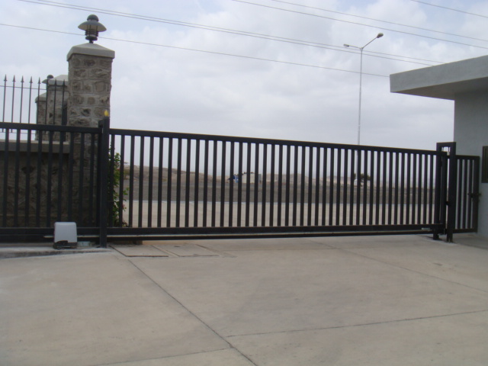
Sliding Gate
- Smooth Safe & economical operation.
- Varied lengths of gates can be fabricated from 1000mm - 12000mm.
- Can be fabricated for gates up to 18000 kgs weights capacity.
- Bottom rail made up of polished bright bar supported with heavy duty beam.
- Bottom roller with high precision bearings
Sliding Gate
- Smooth Safe & economical operation.
- Varied lengths of gates can be fabricated from 1000mm - 12000mm.
- Can be fabricated for gates up to 18000 kgs weights capacity.
- Bottom rail made up of polished bright bar supported with heavy duty beam.
- Bottom roller with high precision bearings
Sliding Gate
- Smooth Safe & economical operation.
- Varied lengths of gates can be fabricated from 1000mm - 12000mm.
- Can be fabricated for gates up to 18000 kgs weights capacity.
- Bottom rail made up of polished bright bar supported with heavy duty beam.
- Bottom roller with high precision bearings
Sliding Gate
- Smooth Safe & economical operation.
- Varied lengths of gates can be fabricated from 1000mm - 12000mm.
- Can be fabricated for gates up to 18000 kgs weights capacity.
- Bottom rail made up of polished bright bar supported with heavy duty beam.
- Bottom roller with high precision bearings
Sliding Gate
- Smooth Safe & economical operation.
- Varied lengths of gates can be fabricated from 1000mm - 12000mm.
- Can be fabricated for gates up to 18000 kgs weights capacity.
- Bottom rail made up of polished bright bar supported with heavy duty beam.
- Bottom roller with high precision bearings
Sliding Gate
- Smooth Safe & economical operation.
- Varied lengths of gates can be fabricated from 1000mm - 12000mm.
- Can be fabricated for gates up to 18000 kgs weights capacity.
- Bottom rail made up of polished bright bar supported with heavy duty beam.
- Bottom roller with high precision bearings

